BSec-NFVO: A Blockchain-based Security for Network Function Virtualization Orchestration
ABSTRACT
Network Function Virtualization (NFV) and Service Function Chaining (SFC) offer flexible end-to-end services that deploy virtual network functions in clouds of competing providers. Orchestration of virtual network functions occurs in a distributed and trustless environment that must tolerate byzantine failures and collusion attacks. This paper proposes BSec-NFVO, a blockchain-based system that secures orchestration operations in virtualized networks, ensuring auditability, non-repudiation and integrity. We propose an NFV-tailored blockchain and a transaction model. BSec-NFVO provides a modular architecture to secure orchestration in a simple and agile way. We develop a prototype of BSec-NFVO for the Open Platform for Network Function Virtualization (OPNFV) with an adaptation of the normal-case of a collusion-resistant consensus protocol. The results show BSec-NFVO incurs low overhead to the cloud orchestrator and presents stable performance as the number of consensus participants increases.
EXISTING SYSTEM
In previous works, the authors of this paper evaluated the performance of service function chains in the Open Platform for Network Function Virtualization (OPNFV) [5] and analyzed the use of blockchain in OPNFV for securing configuration and migration of virtual network functionsIn previous works, the authors of this paper evaluated the performance of service function chains in the Open Platform for Network Function Virtualization (OPNFV) [5] and analyzed the use of blockchain in OPNFV for securing configuration and migration of virtual network functions. Network Function Virtualization (NFV) and Service Function Chaining (SFC) offer flexible end-to-end services that deploy virtual network functions in clouds of competing providers. Orchestration of virtual network functions occurs in a distributed and trustless environment that must tolerate byzantine failures and collusion attacks.
Disadvantages of Existing System:
- Previous works address the problem of security vulnerabilities in multi-tenant and multi-cloud NFV environments.
- More cost.
PROPOSED SYSTEM
This paper proposes, develops, and evaluates BSec-NFVO, a blockchain-based system for agile and secure management of service function chain orchestration operations2. BSecNFVO extends the premises of FCAPS to a multi-domain environment. Our proposal guarantees transparency of orchestration operations and accountability of its authors by immutably logging all instructions that manipulate a service chain. The use of blockchain and public-key cryptography ensures authenticity, integrity and non-repudiation of instructions, which allows confirming provenance. Therefore, BSecNFVO guarantees auditability of the performed operations, which can be used for investigation and legal measures in the case of a security incident. transaction models. We implement a prototype of BSecNFVO in the Open Platform for Network Function Virtualization (OPNFV) with a simplification of a byzantine fault tolerant consensus protocol to provide low-latency consensus while tolerating collusion of up to one third of consensus participants. The results show the delay introduced by the blockchain is not significant, and that BSec-NFVO is more effective in longer service chains. The peak throughput of the prototype is 803.3 transactions per second.
Advantages of Proposed System:
- The Network Function Virtualization (NFV) technology replaces hardware-based network functions by virtual network functions (VNF) that run in commodity machines The Network Function Virtualization (NFV) technology replaces hardware-based network functions by virtual network functions (VNF) that run in commodity machines.
- NFV reduces costs and offers flexible network management by reimplementing middleboxes in software that can be developed by a plethora of providers.
SYSTEM REQUIREMENTS

System Architecture

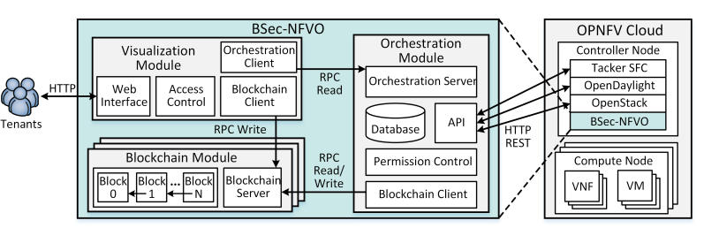
Fig.1 BSec-NFVO Architecture.

Hardware Requirements:

Processor - Pentium –IV
- Speed - 1.1 GHz
- Ram - 256 MB
- Hard Disk - 20 GB
- Key Board - Standard Windows Keyboard
- Mouse - Two or Three Button Mouse
- Monitor - SVGA
Software Requirements:
- Operating System - Windows XP
- Coding Language - Java

